Provider Type: Licensed FCCH
We appreciate your interest in contracting with the Early Learning Coalition of Escambia County to provide this important educational service for our children. Caring for children and providing them with the foundational skills for learning is very important. We require you to do more than just meet the basic health and safety needs of our children, but to also endeavor to provide these children at high risk of school failure with an opportunity to learn and develop so that they are prepared to enter kindergarten ready to learn and succeed.

Who must complete this application? All private providers or public schools who desire to contract with the Coalition to provide school readiness services must complete this application. Completing this application does not guarantee approval to provide school readiness services.

General Instructions:

- Complete all required forms in this package and submit all required supporting documentation.
- The pages labeled Exhibits 1, 2, and 3 are excerpts from the SR contract and will be reinserted into the contract package at contract signing. There are two copies because we need one for each copy of the contract, yours and ours.
- Use the checklist that is Exhibit 2 to keep track the list of supporting documents. In addition to the documents required in Exhibit 2 please provide what is listed below.
- Type or print clearly using black or blue ink.
- Do not use white-out.
- Keep a copy of the application for your records (no copies will be made at time of submission).
- The Coalition Contracts Administrator will review your application and provide you with the status of your application within ten (10) business days.
- Any application that has missing signatures or information, or missing documentation will be returned to the provider in total. The application will be treated as a NEW application upon re-submission.

.

INSTRUCTIONS FOR COMPLETION OF APPLICATION

- New, Updated or Annual Renewal Application: Mark a box indicating whether the application is new, updated, or an annual renewal. (If you provided services to School Readiness (SR) children last year, please mark “Annual Renewal”.)

- Facility Type: Mark a box indicating the type of setting which describes the provider or school. To be eligible to deliver school readiness services, the program must mark one of the listed types of settings. An application is incomplete if a box is not marked.

- Provider’s Demographics: Complete all that apply. Use “N/A” if a box is not applicable

- Corporate Name of Provider or School - Enter the legal name of your business as it appears on your IRS letter or social security card. The legal name of a business often includes “Corp.,” “Inc.,” “Co.,” or similar titles.

- Business Name of Provider or School (doing business as) - Enter provider’s common name if it uses a name that is different from your business legal name. A business name is often referred to as a “fictitious name,” “trade name,” or “DBA” for doing business as.

- Physical Address of Program Site (number and street) - Enter the physical street address of the program site where the SR program is delivered. Include the city, county, and five-digit postal ZIP Code.

- Mailing Address: If your mailing address is different than the physical address, enter that address here.

- Facility Landline, Alternate and Fax Numbers: Enter your business landline, alternate and fax numbers with area codes.

- E-Mails. You must maintain a working e-mail account and you must check your email frequently for information from the Early Learning Coalition of Escambia County.

- Employer Identification Number – Your employer identification number or social security number is requested in accordance with § 119.07(5)(a)(2) and 119-092, F.S. for use in the records and data systems of the Office of Early Learning and The Early Learning Coalition of Escambia County.

Privacy Act Statement
Submission of your EIN or SSN on this form is mandatory. Your EIN or SSN will be used for processing payments to you as a School Readiness provider, reporting those payments for tax purposes, and for routine identification of you as a provider.

- Enter the employer identification number (EIN) of the business (e.g., provider, owner, school district) that will receive payments for the SR program. This nine-digit number is assigned to a business by the Internal Revenue Service. If you do not have an EIN (e.g., family day care home), enter the director’s/operator’s social security number (SSN). An application that does not include an EIN in item 3 or a director’s/operator’s SSN is incomplete and may delay processing of the application. For providers utilizing an EIN, a copy of an IRS record of the EIN must be attached with the application. This record must include the following three items: Official IRS logo, EIN, and legal name.

- For providers utilizing a Social Security number, a copy of the Social Security card must be attached with the application.

- Florida Department of Children & Families (DCF) Identification Numbers: If the provider or school is licensed or registered by the Florida Department of Children & Families or, in some counties, by a local licensing agency, enter the DCF number in this section. Faith based providers that claim exemption from licensure are required to register with DCF and are assigned an exempt number. Faith-based providers will also need to enter your number in this section.

- Legal Owner Information: If you are a private that is owned by another business, enter a contact name for the owner, the legal name of the owner’s business, and a daytime phone number you are a public school or large corporate entity, enter the name and daytime phone number of the staff who is coordinating the School Readiness program.

- Name of Director/Operator/Principal - Enter the full name of the provider’s or school’s director/operator/principal with a daytime phone number.

- Facility Days of Operation: Mark the days of the week your facility is in operation.

- Facility Times of Operation: List the times your facility is in operation.

- Facility Ownership Information: Please answer all questions pertaining to the lease/ownership of your facility

- Transportation Insurance: School Readiness providers that provide transportation services must provide verification of transportation insurance for transportation of children in their program. The provider will need $5,000 per person/a minimum of $100,000 each period ($5,000 each if goes above $100,000, i.e. a bus), at least $100,000. Vehicle must be checked and cleared by a mechanic annually (DCF has forms) and a current Driver’s License/CDL if vehicle is 16 passengers or more.

- Gold Seal Designation: Mark whether the provider holds a current Gold Seal Quality Care designation issued by the Florida Department of Children and Family Services (DCF). If the provider is Gold Seal accredited, list the name of the accrediting agency and expiration date. The provider must submit a copy of the official State of Florida Gold Seal certificate issued by the Department of Children and Family Services with this application.

- Accreditation: Mark whether the provider holds a current accreditation by another organization and list the expiration date. Submit a copy of the accrediting agency certificate.

- Provider Certification: The applicant is required to read the certification statement sign and print name, list title and date of application. For private providers, the applicant must be the owner, director, or operator. For public schools the applicant must be the principal or designated school district staff.

Note:

General Liability Insurance:
In accordance with 1002.88(1) (l) and (m), F.S., All School Readiness providers are required to maintain general liability insurance of $100,000 single incident/ $300,000 cumulative incident. The Provider must add The Early Learning Coalition of Escambia County as certificate holder and additional insured

Workers’ Compensation and Unemployment Compensation
In accordance with s. 1002.88(1) (n), F.S., Provider agrees to obtain and maintain any required workers’ compensation insurance under Chapter 440 F.S., and any required reemployment assistance or unemployment compensation coverage under Chapter 442 F.S. Provider agrees to provide the Coalition with evidence of worker’s compensation insurance coverage. (Required if provider employ 4 or more employees)

Curriculum and Character Development Program
In accordance with Section 1002.88(2)(1)(f) and 1002.88 (1)(g),FS, school readiness providers are required to use an approved curriculum and a implement a character development program to develop basic values.

School Readiness Child Care Provider Application
Fiscal Year 2016-2017

- Application:

New _____ Annual Renewal _____ Updated _____ If update, Effective Date: _______________

2. Facility Type: (Check all that apply)

☐Licensed Child Care Facility ☐ Public School ☐Licensed Large Family Child Care

☐Registered Family Child Care Home ☐Informal Provider ☐Licensed Family Child Care Home

☐Religious Exempt Child Care Facility ☐Charter School ☐ Private School

3. Provider’s Demographics:

- Name of Provider-Corporation or School:
- Business Name (Doing Business As - DBA)
- Physical Address: City: Zip Code:

- Mailing Address (if different): City: Zip Code:

- Facility Telephone Number: (Landline): | Alternate Number: |  | Fax Number:
- E-Mail:

- Employer’s Identification #: |  | - DCF Lic /Reg/Exempt #:
- Legal Owner:  Phone: |  | - Director’s/Principal Name:  Phone:
- Facility Days of Operation: (Check all that apply)  S____M____T_____W_____Th_____F_____S_____ |  | - Facility Times of Operation:  ______________AM _____________PM

4. Facility Information:

- Do you lease or own your facility? Own____ Lease_____
- If owned or leased, is the property zoned to allow a child care business? Yes_____ No _____
- If leased does your lease agreement and/or landlord specifically allow use of the property for a child care business? Yes _____ No _____ N/A _____
- If your lease does not expressly allow or disallow use of your facility as a child care facility, has your landlord or owner either verbally or in writing been informed of your intent to operate a child care business on the property? Yes _____ No _____ N/A _____
School Readiness Child Care Provider Application
Fiscal Year 2016-2017

- Do you provide transportation? Yes ____ No____ School Readiness providers that provide transportation services must provide verification of transportation insurance for transportation of children in their program. A copy of your transportation insurance must be submitted with application.

(Check all that apply)
 | From school to site |  | From site to home
 | To school from site |  | To site from home
 | Near public transportation |  | In walking distance to school (list sch. names):
 | By school bus or van

- Gold Seal: Are you are a Gold Seal Accredited site? Yes ______ No______
(Please enclose a copy of your Gold Seal Certificate)

- ACCREDITATION - Are you accredited by an accrediting agency? (Check all that apply) A copy of your certificate is required for accreditation to be listed. *REQUIRED
Accrediting Agency |  | Effective Date | End Date
☒ | NOT ACCREDITED
☐ | ASSOCIATION OF CHRISTIAN SCHOOLS INTERNATIONAL
☐ | ASSOCIATION OF CHRISTIAN TEACHERS AND SCHOOLS
☐ | ACCREDITED PROFESSIONAL PRESCHOOL LEARNING ENVIRONMENT
☐ | COUNCIL OF ACCREDITATION
☐ | FLORIDA COALITION OF CHRISTIAN PRIVATE SCHOOL ACCREDITATION
☐ | FLORIDA LEAGUE OF CHRISTIAN SCHOOLS
☐ | GOLD SEAL QUALITY CARE ACCREDITATION
☐ | GREEN APPLE ASSOCIATION OF CHRISTIAN SCHOOLS
☐ | NATIONAL ACCREDITATION COMMISSION FOR EARLY CARE AND EDUCATION PROGRAMS
☐ | NATIONAL ASSOCIATION FOR THE EDUCATION OF YOUNG CHILDREN
☐ | NATIONAL ASSOCIATION FOR FAMILY CHILD CARE
☐ | NATIONAL COUNCIL FOR PRIVATE SCHOOL ACCREDITATION
☐ | NATIONAL EARLY CHILDHOOD PROGRAM ACCREDITATION
☐ | SOUTHERN ASSOCIATION OF COLLEGES AND SCHOOLS
☐ | UNITED METHODIST ASSOCIATION OF PRESCHOOLS
☐ | OTHER (List Below)
☐
☐
☐

School Readiness Child Care Provider Application
Fiscal Year 2016-2017

- CERTIFICATION FOR SCHOOL READINESS CONTRACTED PROVIDERS

I certify that:

- I have examined this application and, to the best of my knowledge and belief, the information provided is true and correct. Including all attachments.
- If any of this information changes, I understand that I must submit said changes to the Coalition.
Signature: ________________________________________________________________________
Owner / Director / Operator / Principal / School District Staff / or Authorized Personnel

Print Name: ________________________________________________________________________
Owner / Director / Operator / Principal / School District Staff / or Authorized Personnel

Title: _____________________________________________________________________________

Date: _______________________________________

School Readiness Application Documentation Submission Checklist
Fiscal Year 2016-2017

Please use the checklist below to ensure you have all required documentation to submit with your school readiness application.
Copy of DCF License, Registration Certificate or DCF Religious Exemption Letter
If Accredited, Copy of Accreditation Certificate
If Gold Seal, Copy of Gold Seal Certificate
Copy of Current Accrediting Agency Inspection report (License Exempt Centers Only)
Copy of Current General Liability Insurance Certificate
Copy of Current Worker’s Compensation/Unemployment Compensation Coverage or Verification of Waiver. (Note: Verification of Worker’s Compensation/Unemployment Compensation Coverage or Waiver is not required to be submitted with your application, but must be obtain, maintain and available during monitoring.)
Copy of Current Transportation Insurance Certificate (If you transport children)
Copy of IRS EIN Letter OR If you do not have an EIN a copy of your Social Security Card
Copy of DCF or OEL Health & Safety Checklist (Registered & Informal Homes, Exempt Private and Non-Public Schools)
Owner /Operator Form Completed. (This meets the requirement for Item 6 of Exhibit 2).
Direct Deposit Authorization Form (Attach Voided Check or Bank Letter)
Copy of Emergency Preparedness Plan or your company plan
Completed W-9 Form
Current Sunbiz Printout identifying the office, director or authorized person(s).

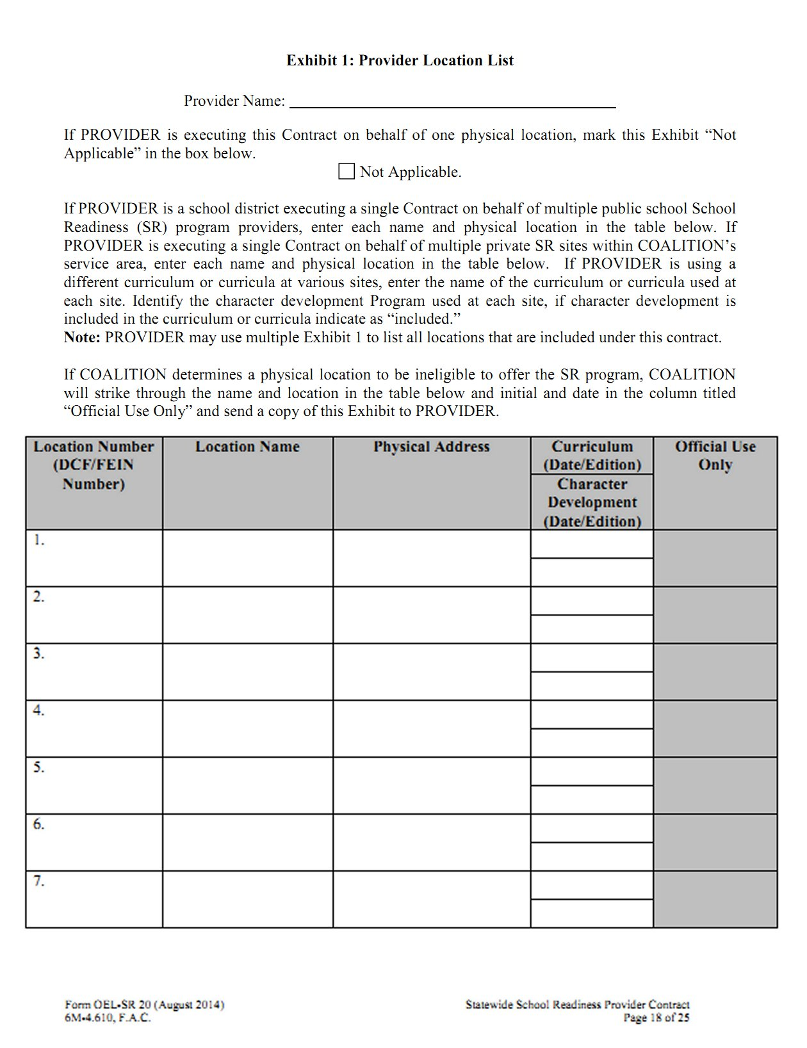
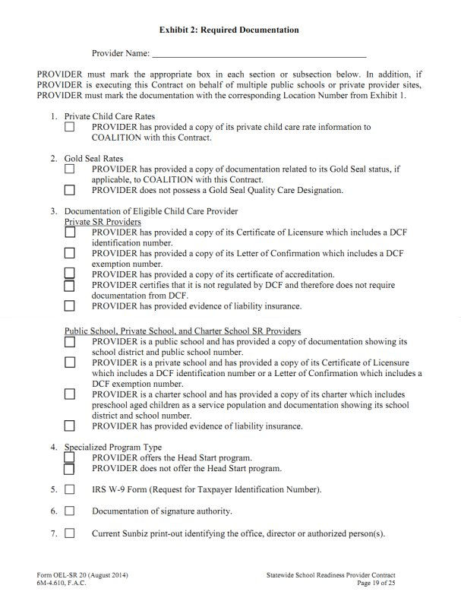
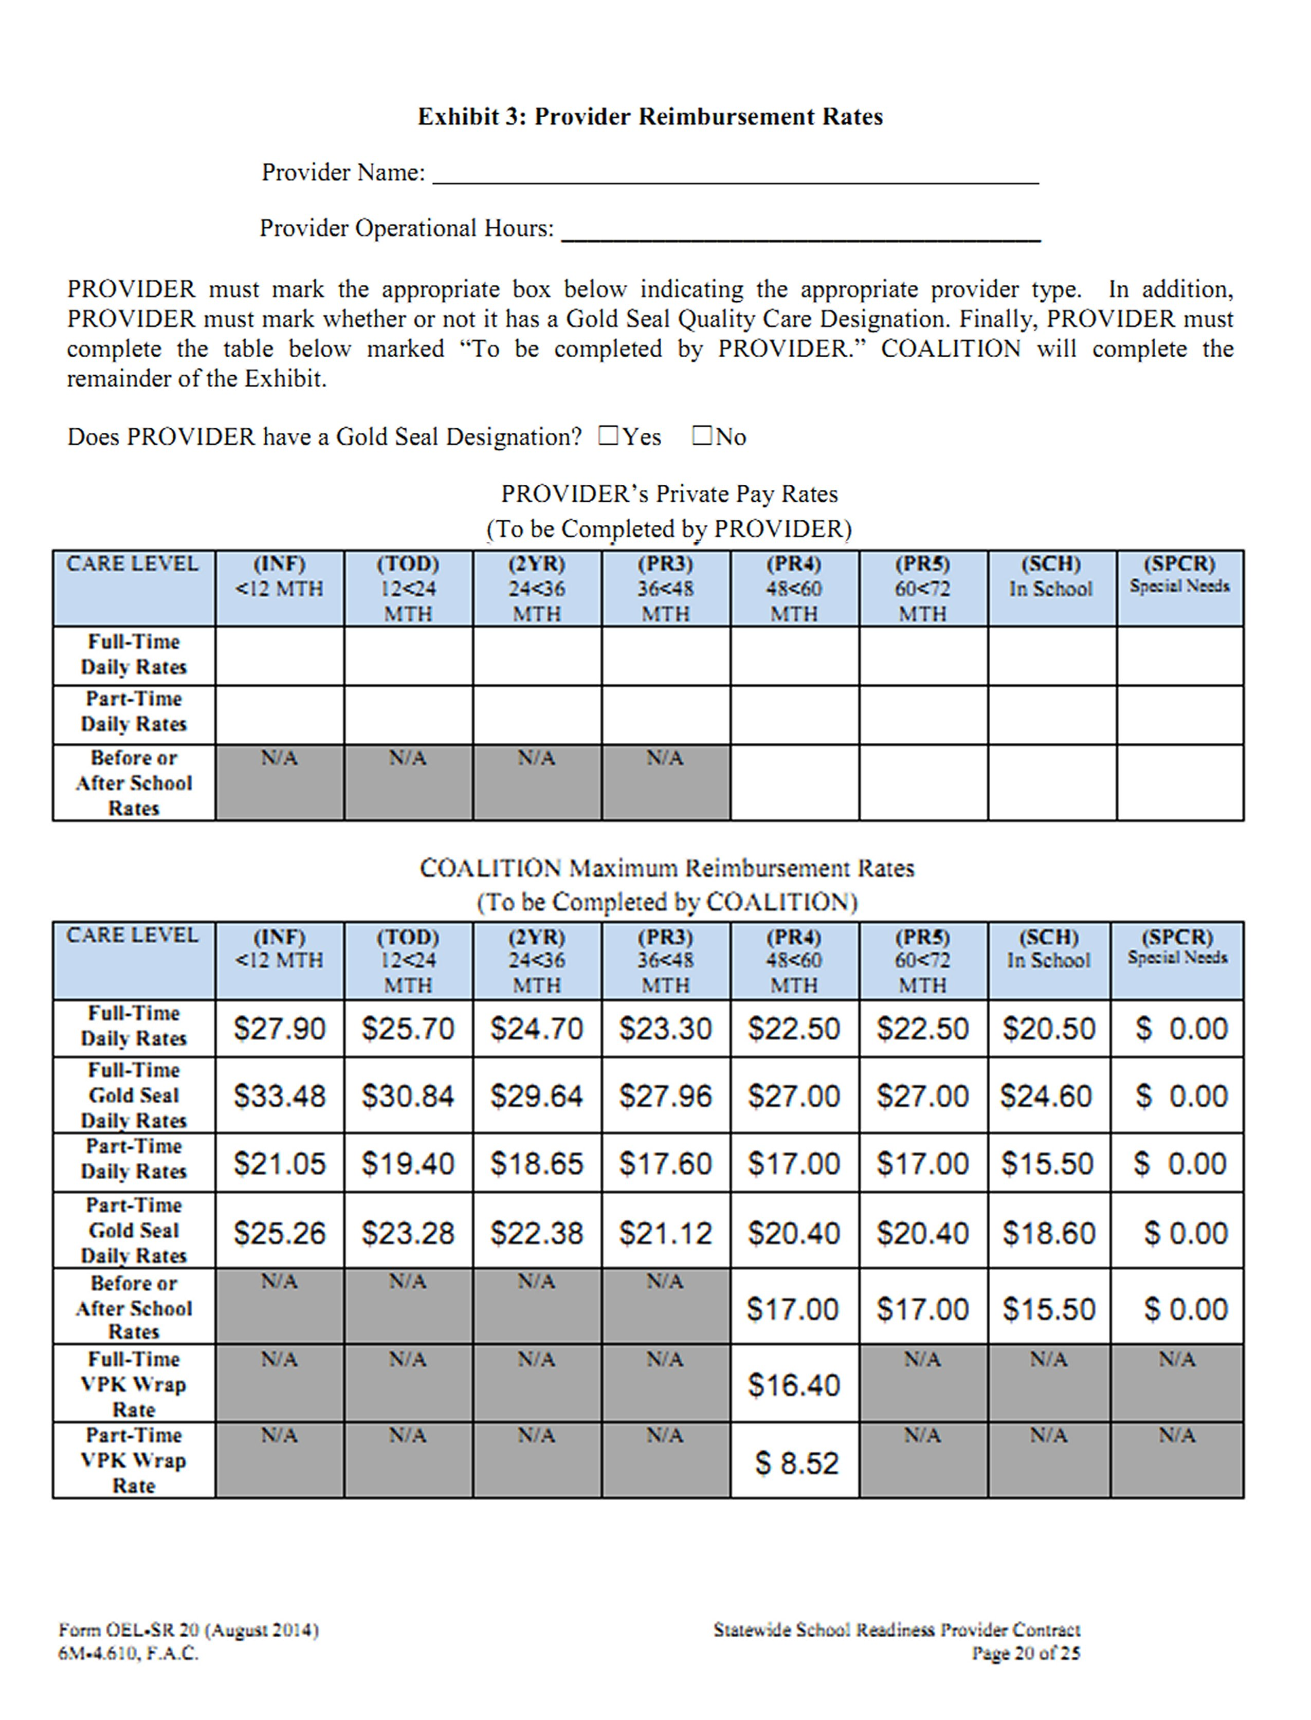

Exhibit 2 (Item 6)
Owner /Operator Information

Please provide the following information for your School Readiness Program. Any changes must be reported to the Coalition within fourteen (14) calendar days of the change.
Failure to report changes may result in the termination of the school readiness contract.

It must be indicated who has authorization to sign contractual and financial documents on behalf of the child care facility. This form must be signed by the owner, chief executive, or corporate officer granting permission to the director of the program to execute the services agreement contract.

New: _______ Annual Renewal: _______ Update: _______ If Update, Effective Date: _____________

Facility Name: ______________________________________________________________________

Title: ☐Owner ☐Board of Director Member ☐Chief Executive ☐Corporate Officer

Full Name: _________________________ Signature: ______________________ Date: ___________

Name of individual(s) listed below whom are authorized to sign all School Readiness contractual and financial documents for the child care facility listed on this application:

1. Full Name: _________________________________ Title: _________________________________

Signature: _________________________________ Date: _________________________________

2. Full Name: _________________________________ Title: _________________________________

Signature: _________________________________ Date: _________________________________

3. Full Name: _________________________________ Title: _________________________________

Signature: _________________________________ Date: _________________________________

For monitoring, licensing, health inspections or audit reviews, list the names of individual(s) who are authorized to act in place of the director if the director is not on-site. Persons acting in place of the director must be at least 21 years of age.

1. Full Name: _________________________________ Title: __________________________________

Signature: __________________________________ Date: _________________________________

2. Full Name: _________________________________ Title: _________________________________

Signature: __________________________________ Date: _________________________________

For Family Child Care Homes – Please list name of Substitutes(s):

1. ________________________________________ 2. __________________________________________

BANKING INFORMATION

It is required that early childhood providers who contract with Early Learning Coalition utilize direct deposit (electronic funds transfer) (EFT) through the provider’s banking institute to be paid for School Readiness services. Exceptions must be approved in writing by the Executive Director. Please provide your banking information below.

NOTE: Please attach a voided check or documentation from provider’s bank verifying Account Holder’s Name, Account Number, and Routing Number.

Bank Name | Name on Account
Account Type | ____ Checking account  Savings account
Bank Address | Account Number
 | Routing Number
 | Name of Authorized Signer
Bank Phone Number | Name of 2nd Authorized Signer (if applicable)

Thank you for your cooperation in gathering this important information. You may contact this office at any time to update your information. Banking changes may result in an EFT payment delay due to banking requirements. Your reimbursement specialist is available to answer any questions you might have.

Comments/Questions:

Director/Operator signature _________________________________ Date: __________________

Reimbursement Signature __________________________________ Date: __________________

Emergency Preparedness
Plan

Name of Program: ________________________________________________
Address: _______________________________________________________________
City, State, Zip Code: ______________________________________________
Emergency Phone Contact Number: ____________

This Plan was prepared BY:
Name: _______________________________________Position: ______________________________
City, State, Zip Code: _________________________________________________________________

___________________________________________________ _______________________
Signature Date

Purpose
The (Name of Provider) _______________________________________ shall develop a written emergency preparedness plan to include, at a minimum, procedures to be taken by the facility in the event of a disaster or emergency. The plan shall include how the provider will meet the needs of children (including children with special needs) and staff by establishing a designated safe area, will know what documents and items to bring, will have a list of parents and emergency contacts and in the event of relocation will have procedures in place to safely and calmly relocate the children and staff and facilitate parent/guardian reunification.
The following are examples of a disaster or emergency which may cause relocation:
Hurricane Active Shooter Aircraft Accidents
Facility Fire Workplace Violence Kidnapping
Tornadoes Bomb Threats Train Derailments
Floods Wildfires

Location of Plan
(Name of the Provider)_____________________________________________will have a copy of their Emergency Preparedness Plan posted in sight for all parents, staff and visitors to view. An updated copy of the Emergency Action Plan will be submitted to the Early Learning Coalition of Escambia County whenever changes occur or at least annually with contract application.
Emergency Policy
(Name of the Provider)____________________________________________ will follow the rules for Physical Environment under the Florida Administrative Code specifically rule 65C-22.002(7) (a)-(m) for Fire and Emergency Safety. The Owner/Director should assume responsibility for emergency actions until the arrival of emergency service personnel.
In the absence of the facility director/owner, the following person(s) will take charge:
Primary:
Secondary:
Notification of Emergencies
In the event of an emergency, the Director and Staff will make sure all children are in a safe place or evacuated off the premises to a safe location if necessary. Should an evacuation happen, Parents/Guardians will then be contacted by (Staff Member) _______________________ at the evacuation location to come and pick up their child (ren).
After all parents/guardians have been contacted, the Director will contact the Early Learning Coalition of Escambia County at (850) 595-5400 to inform them of the situation and the status of their building. After hours call 850-287-0650. Should (Name of Provider) __________________________________ not be able to resume normal business practices, it is the right of the Early Learning Coalition of Escambia County to begin notifying parents of their right to transfer their child to a new location until (Name of Provider) ________________________________________ is able to resume normal business.
Upon notification, the Early Learning Coalition of Escambia County will send staff out to observe the building affected during the emergency to make sure the space passes a health and safety inspection. Should the space not pass inspection, the staff will inform the Director of changes that need to be made before children may return to the building. Should the building be in a condition that is not immediately repairable, the Director will meet with the Coalition staff to discuss their options.

(Name or Provider)______________________________________ is responsible for notifying their licensing/accrediting agency within 24 hours of the incident.

Exit & Escape Procedures
Should the children need to be relocated from the building, an attendance roster (sign/in-out sheet) with all the children in attendance will be used to take attendance before leaving the building, after boarding transportation and after unloading the transportation at the new location. Additionally, all Sign-in/Sign-out forms shall be used to verify child attendance and departure. Emergency routes are posted in the building and have been practiced monthly so all children and staff are aware of the procedures.
In the event of an evacuation (Name of Provider) ______________________________will move all the children to:
Name and Location of Evacuation Site:
Name of Provider: ____________________________________________ will transport all children by (means of transportation) ________________________________ to the evacuation site.
Please provide the Coalition with a document from the evacuation site that approval has been granted for your program to use this location as a shelter until all children are picked up.
(Name of Staff) shall attend to any children identified with “Special Needs”; to include insuring any medication or equipment that is on site for a child will be taken with the child in the event of the emergency evacuation and relocation.
Reporting Emergencies
(Name of Staff) _______________________________________________ will be responsible for bringing all emergency contact information for all children to the evacuation site.
(Name of Staff)________________________________________________ will begin contacting parents after attendance has been taken and all children have been accounted for.
Type of Emergency | Contact | Phone Number
Fire
Weather Related
Bomb Threat
Medical Emergency
Flood
Others

Emergency Numbers for Parents/Guardians Shall be Prominently Posted near Each Telephone
An updated computer generated Roster with Parent/Guardian & Phone Number
Information may be used in lieu of this form, BUT MUST BE CURRENT & POSTED!

This list should be updated upon enrollment or disenrollment of any child.
Name of Child | Name of Parent/Guardian | Phone
NOTE: A COPY OF THIS LIST SHALL NOT BE PROVIDED TO COALITION

Accounting for Employees
A list of employees and emergency contact information should remain current.
Name | Phone

Notes:
1. Copy of this emergency action plan shall be provided to every employee in organization that is expected to deal with emergencies.
2. A copy of this list shall not be provided to the Coalition.

