Early Learning Coalition of Escambia County

Voluntary Pre-Kindergarten (VPK) Contract Application
Fiscal Year 2019-2020

The Early Learning Coalition of Escambia County welcomes you to the 2019-2020 VPK Program year. We have provided the checklist below to assist you in completing your VPK Provider application. To be considered for approval, you must fully complete, sign and date all application forms and submit them along with the appropriate documentation.

Who must complete this application? All private providers or public schools who desire to contract with the Coalition to provide Voluntary Pre-Kindergarten services must complete this application. Completing this application does not guarantee approval to be awarded a contract or approval to provide Voluntary Pre-Kindergarten services.

Contract Application Prerequisite: As a prerequisite all current and prospective Providers must be properly registered in the Florida’s Early Learning Provider Services Portal for the coming fiscal year. This application package will only be accepted from Providers who have already completed, a received Coalition approval of their Provider Portal Profile for Fiscal Year 2019/2020.

Contract Approval (Electronic Signing) Prerequisite: The new Statewide Voluntary Prekindergarten Provider Contract, Form OEL-VPK 20, paragraph 10 (b) states:
10. Adherence to Requirements – b. PROVIDER agrees to participate in a VPK orientation prior to the execution of the contract if offered by the coalition.
This Coalition does offer an orientation and no contracts will be signed by the Coalition until after an authorized representative of the Provider has attended the orientation.

You need not complete a paper copy of Forms OEL-VPK 10 and OEL-VPK-11A & 11B. The completions on the VPK Application on the provider portal will automatically generate these forms.

1. Requirements of the Statewide Provider Registration Application Form (OEL VPK-10):
A copy of the forms listed below must be uploaded to your Provider Profile under Documentation tab in the Provider Portal * Required*)
- Copy of DCF current Licensed
- Copy of current Accreditation Certificate through approved accrediting agency
- Copy DCF Exemption Letter
- Copy of current Gold Seal Certificate (if applicable)

(a) VPK Director Verification
A copy of the forms listed below must be uploaded to your provider profile under the VPK Application in the Provider Portal * Required*)
- DCF transcript verifying Director’s Credential, either
- VPK Exempt (original issued prior to 12/31/2006) or
- VPK Endorsed (required if issued after 12/31/2006); and,
- Standards for Four-Year-Old or Florida Standards for Four Year; and,
- Emergent Literacy for VPK Instructors

- As of October 15, 2017, Directors Seeking VPK Director’s Endorsement are ALSO required to have:
- Language & Vocabulary in VPK Classroom (DOE Course) 5 hours online course
- Mathematical Thinking for Early Learners (DOE Course) 5 hours online course

- OR for Public Schools ONLY the following can be substituted for a VPK Director’s Credential:
- State of Florida Professional Educator’s Certificate (School Principle – All Levels) from the DOE.

- And for everyone:
- Director’s Level II background screening (completed within the last five years)
- DCF Child Care Attestation of Good Moral Character (DCF Current)

Voluntary Pre-Kindergarten (VPK) Contract Application
Fiscal Year 2018-2019

2. Class Registration Application-Instructors Form (OEL VPK-11A):
List all Lead Teacher(s), Substitute(s), and Aide/Assistant(s) using legal name of staff. Class size cannot exceed 11 students with one instructor. An Aide/Assistant teacher is required if there is an increase of children in the classroom from 12 to 20). Note: Item 10 of the VPK-11A pertains to the start and end date of each teacher (instructor) in the classroom. Enter the date the instructor listed will begin instructing the VPK class.
A copy of the forms listed below must be uploaded to your provider profile under the VPK Application in the Provider Portal * Required*)

- VPK Instructor (Lead Teacher)
- DCF Current Training Transcripts verifying:
- Staff Credential (Lead Teachers)
- Four-Year-Old Standards/Implementing the Standards for 3-year-Old to Kindergarten
- Completion of 40 Clock Hours
- Emergent Literacy Training, OR:
- OR for Public Schools
- State of Florida Professional Educator’s Certificate (with a Primary or Pre-Kindergarten designation) from the Department of Education.
- AND:
- Level II background screening (completed within the last five years)
- Child Care Attestation of Good Moral Character (DCF Current)

- Substitutes for Lead Teachers
- DCF Current Training Transcript verifying:
- Meet any requirements for a lead teacher, OR:
- Completion of DCF 40-Clock Hour Introductory Child Care Training Course
- Emergent Literacy Course
- AND:
- Level II background screening (completed within the last five years)
- Child Care Attestation of Good Moral Character (DCF Current)

- Secondary Instructors (Aide/Assistant Teacher):
- DCF Current Training Transcripts verifying:
- Completion of 40 Clock Hours
- Emergent Literacy Course
- Copy of Level II background screening (completed within the last five years)
- Child Care Attestation of Good Moral Character ( DCF Current)
3. Class Registration Calendar Form (OEL-VPK 11B) – (Must Provide 540 Instructional Hours)
As part of the application process you will need completed your VPK Application on the Provider Portal, the contents will download into Form VPK 11B.

- Copy of Provider’s Attendance Policy VPK programs
- A copy of your VPK attendance policy must be upload to your VPK application on the Provider Portal.

BANKING INFORMATION

It is required that early childcare providers who contract with Early Learning Coalition utilize direct deposit (electronic funds transfer (EFT) through the provider’s banking institute to be paid for School Readiness and VPK services. Exceptions must be approved in writing by the Executive Director. Please provide your banking information below.
NOTE: Please attach a voided check or documentation from provider’s bank verifying Account Holder’s Name, Account Number, and Routing Number.
Bank Name | Name on Account
Account Type: (Check One)  Business_________ Personal __________ | ____ Checking account  Savings account
Bank Address | Account Number
 | Routing Number
Bank Phone Number | Name of Authorized Signer
 | Name of 2nd Authorized Signer (if applicable)
Thank you for your cooperation in gathering this important information. You may contact this office at any time to update your information. Banking changes may result in an EFT payment delay due to banking requirements. Your reimbursement specialist is available to answer any questions you might have.
Comments/Questions:

Director/Operator signature: _________________________________ Date: __________________

Coalition Use Only:
☐ No Change to Bank Info/Bank Info Verified in EFS ☐ Bank Info Changed/ EFS Updated/Changed
☐ New Provider- Date entered in EFS _________

Processed by (Coalition Staff Signature): __________________________________Date: _____________________

Voluntary Pre-Kindergarten
Owner /Operator Information (FY 2019-2020)

This form serves as a requirement of your Statewide Voluntary Prekindergarten Provider Contract.

Facility Name: __________________________________________________________________________

New: ______ Annual Renewal: _______ Update: _ ____ If Update, Effective Date: ___________

Signature of authorizing personnel: _________________________ Print Name: ___________________
Title: ☐ Owner ☐ Board of Director Member ☐ Corporate Officer ☐ Administrator of Program ☐ Other ___________________

Please provide the following information for your Voluntary Prekindergarten Program. Any changes must be reported to the Coalition within fourteen (14) calendar days of the change. Failure to report changes may result in the termination of the Voluntary Prekindergarten contract.

It must be indicated who has authorization to sign contractual and financial documents on behalf of the child care facility. This form must be signed by the owner, chief executive, or corporate officer granting permission to the director of the program to execute the services agreement contract.

1. Full Name: ________ _______ ________________________ Title: ________________________________

Signature: ______ _____ _________ _________________ Date: ___ ____________________________

2. Full Name: ____________________ ___________ ________ Title: ________________________________

Signature: ______________ __________ _ _____ ______ Date: ____ ___________________________

3. Full Name: ____________________________ ________ ___ Title: ________________________________

Signature: _________________ ____________ ______ ____ Date: _________ ______________________

For monitoring, licensing, health inspections or audit reviews, list the names of individual(s) who are authorized to act in place of the director if the director is not on-site. Persons acting in place of the director must be at least 21 years of age.

1. Full Name: _______________________________________ Title: ________________________________

Signature: ______________ _________________________ Date: _____ __________________________

2. Full Name: _______________________________________ Title: ________________________________

Signature: ___________________ ____________________ Date: ________ _______________________

Advisory Note: Per Rule 6M-8.301 Standard Statewide Provider Contract for the Voluntary Prekindergarten Program all persons signing this document are presumed to be in an ownership and/or management position, and as such are considered an “individual associated with provider” as defined in the Rule. All such persons are therefore subject to the consequences of any actions taken with regard to this contract; to include revocation of eligiblity to provide Voluntary Pre-Kindergarten services in the event this contract is terminated for cause. Additionally, Directors and Assistant Directors are by their position considered to be an “individual associated with provider”, and are also subject to the consequences of all contract actions. A copy of this rule is attached to the application for your review.

6M-8.301 Standard Statewide Provider Contract for the VPK Program.
(1) Early learning coalitions may not execute a provider contract with a VPK provider before the VPK provider has registered with the coalition and the coalition has determined the VPK provider’s eligibility to offer VPK services in accordance with Rule 6M-8.300, F.A.C.
(2) Beginning with the 2017-2018 VPK Program Year, All VPK providers which register to offer the VPK program must execute Form OEL-VPK 20, including either Form OEL-VPK 20PP or Form OEL-VPK 20PS as appropriate. A coalition must be a party to a provider agreement. A school district may sign a single provider agreement on behalf of all public school VPK providers in the district. The owner or manager of multiple private VPK providers may sign a single provider agreement on behalf of all of his or her private VPK providers.
(3) The “State of Florida Statewide Voluntary Prekindergarten Provider Contract (Form OEL-VPK 20)” dated October 2016, is hereby adopted and incorporated by reference. All VPK providers, private or public school, must execute this document to deliver the VPK program. The incorporated form is available from the Office of Early Learning, 250 Marriott Drive, Tallahassee, FL 32399 or at http://www.flrules.org/Gateway/reference.asp?No=Ref-07578.
(4) The “State of Florida Statewide Voluntary Prekindergarten Provider Contract Private Provider Attachment (Form OEL-VPK 20PP),” dated October 2016, is hereby adopted and incorporated by reference. This attachment becomes part of the contract for all private providers that execute the contract adopted in subsection (3). The incorporated form is available from the Office of Early Learning, 250 Marriott Drive, Tallahassee, FL 32399 or at: http://www.flrules.org/Gateway/reference.asp?No=Ref-07579.
(5) The “State of Florida Statewide Voluntary Prekindergarten Provider Contract Public School Attachment (Form OEL-VPK 20PS),” dated October 2016, is hereby adopted and incorporated by reference. This attachment becomes part of the contract for all public schools that execute the contract adopted in subsection (3). The incorporated form is available from the Office of Early Learning, 250 Marriott Drive, Tallahassee, FL 32399 or at: http://www.flrules.org/Gateway/reference.asp?No=Ref-07580.
(6) Before VPK services are delivered by a provider, the VPK provider and the coalition shall fully execute the Provider Contract and the appropriate private or public provider attachment. A coalition shall execute and retain this Contract electronically in compliance with Section 668.50, F.S., The Uniform Electronic Transaction Act.
(7) Neither a coalition nor a VPK provider may omit, supplement, or amend the terms and conditions of the Provider Contract or include any attachments, addenda, or exhibits to the contract except described in this subsection. Form OEL-VPK 20PP and Form OEL-VPK 20PS are approved attachments to the provider contract. The coalition and VPK provider may agree to amend the provider contract if the specific type of amendment is identified on Form OEL-VPK 20A (October 2016), titled Amendment to Statewide Voluntary Prekindergarten Provider Contract, which is hereby incorporated by reference. The incorporated form is available from the Office of Early Learning, 250 Marriott Drive, Tallahassee, FL 32399 or at http://www.flrules.org/Gateway/reference.asp?No=Ref-07581. Form OEL-VPK 20A shall be executed by both the coalition and the VPK provider.
(8) For the purpose of this subsection “individual associated with a provider” means an individual or family member of an individual who, regardless of compensation, holds a management position, oversees the operations of a provider, or is an officer, shareholder, beneficial owner or member of the board of directors of a provider. A provider shall not be eligible to contract to offer the VPK program if any of the following circumstances apply:
(a) The provider is on the United States Department of Agriculture National Disqualified List;
(b) An individual associated with the provider was, or is, associated with another provider that is on the United States Department of Agriculture National Disqualified List;
(c) The provider has been terminated from participation in the program due to fraud and is currently not eligible to participate in the VPK program, or
(d) An individual associated with the provider was, or is, associated with another provider that has been terminated from participation in the program due to fraud and is currently not eligible to participate in the VPK program.
(e) The provider is currently ineligible to participate in the program pursuant to Section 1002.67(4), F.S.
(f) An individual associated with the provider was, or is, associated with another provider that is currently ineligible to participate in the program pursuant to Section 1002.67(4), F.S.
(g) For multi-site providers, such as corporate chains or school districts, VPK program ineligibility identified in paragraphs (e) and (f) above, is per site and may not apply to all locations unless specifically determined otherwise by the coalition. In determining ineligibility of multi-site providers, the coalition shall consider the following factors: the severity of the provider’s actions leading to the ineligibility, the health, safety and welfare of children enrolled at the provider sites, the financial impact of the provider’s actions, the impact that ineligibility would have upon the local community, consistency with coalition’s actions against other providers for similar violations of the Contract or program requirements, the length of time that provider provided services under the Contract with the coalition, and whether the provider had previously violated the terms of the Contract and prior contracts with the coalition.
(h) For providers removed from eligibility due to noncompliance specifically related to VPK pre- and post-assessment or VPK readiness rates under Section 1002.67(4), F.S., the removal from eligibility applies to VPK program type (school-year or summer) and therefore, in paragraphs (e) and (f) above, ineligibility to contract is per program type.
(9) Transfer of ownership. In the event of a change of ownership, sale, sale of assets, conveyance of ownership or other transfer of ownership interest, the provider shall notify the coalition no later than 30 calendar days prior to the transfer of ownership. The coalition and the new owner shall execute a new contract for VPK services, provided the new owner meets the eligibility requirements of Sections 1002.55, 1002.61, and 1002.63, F.S., and is not disqualified from contracting pursuant to subsection (8) of this rule. Upon receipt of a request for a new contract due to a transfer of ownership, the coalition shall have up to thirty (30) calendar days to execute or decline a new contract. This timeline may be extended if all prerequisite requirements have not been met.
(10) Form OEL-VPK 20B (October 2016), titled VPK Logotype Usage and Brand Guidelines, is hereby incorporated by reference. The incorporated form is available from the Office of Early Learning, 250 Marriott Drive, Tallahassee, FL 32399 or at http://www.flrules.org/Gateway/reference.asp?No=Ref-07582.
Rulemaking Authority 1001.213, 1002.79 FS. Law Implemented 1002.55(3)(i), 1002.61(3)(b), 1002.63(3)(b), 1002.75(1), 1002.91(5), (7) FS. History–New 8-17-06, Amended 5-24-07, 12-21-10, Formerly 60BB-8.301, Amended 4-9-15, 12-18-16.

Early Learning Coalition of Escambia County

VPK Provider Profile - FY 2019-2020

Please complete and turn in with your application.
Provider Name:
Address:
Zip Code: |  |  | Phone Number:
Director Name:
VPK School Year: 540 Hours ___________ VPK Summer: 300 Hours___________

Teacher/Child Classroom Ratio: Fall - 1:11 or 2:20 or Summer – 1:12

Provider Type - Check all that apply:
 | Child Care Center |  | Family Child Care Home |  | Public School
 | Faith Based |  | Non-Public School |  | Charter School
 | Head Start |  | Gold Seal Accredited

VPK Readiness Rate for School Year 2017-2018 __________

VPK Program Dates: | Begin Date: | End Date:
VPK Program Daily Hours: | From: | To:

Lead Teacher Credential Level: _______________________________________________________________________________________________

Program Curriculum: __________________________________________________________________________________________________________

Please check all that apply: |  |  | List Cost or check N/A:
Before/After School Available | Yes ____ | No ____ | Cost: $ | N/A_____________
Transportation Available | Yes ____ | No ____ | Cost: $ | N/A ____________
Meals Available | Yes ____ | No ____ | Cost: $ | N/A ____________

Program Description: __________________________________________________________________________________________________________
____________________________________________________________________________________________________________________________________
____________________________________________________________________________________________________________________________________

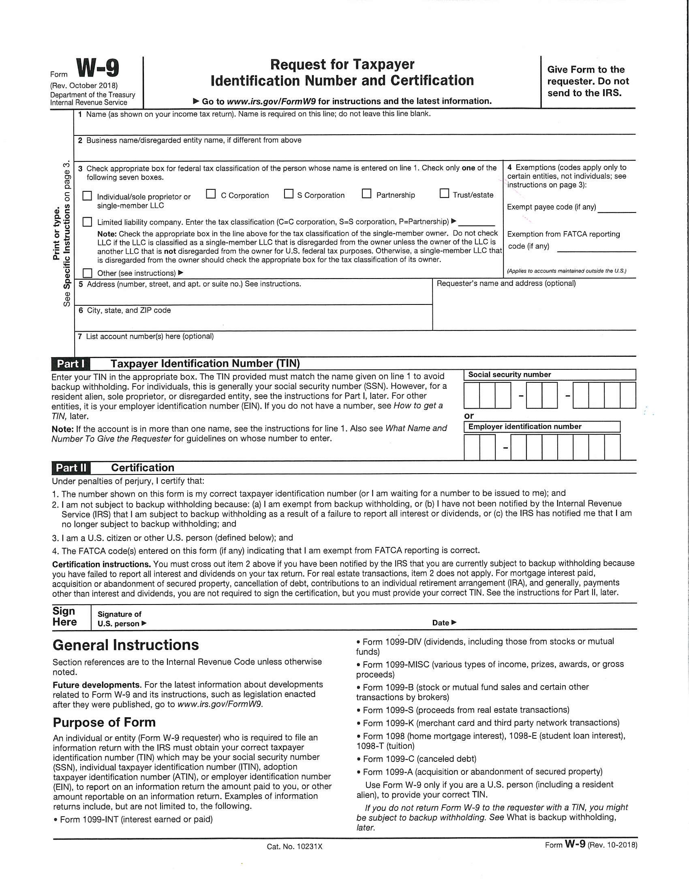

Voluntary Pre-Kindergarten Application Documentation Submission Checklist

Fiscal Year 2019-2020
For Providers Use

Documentation in the checklist below will need to be submitted back with your VPK application.
Copy of Current Accrediting Agency’s annual Inspection report (License Exempt Centers Only)
VPK Calendar Worksheet (Dates should correspond with your calendar on the VPK Application on the provider Portal)
Copy of IRS FEIN Letter
Completed Owner/Operator Form. A copy must also be uploaded in your Provider Profile. On your Dashboard click on “Documents” in the menu. Then click on “View/Update” and upload file in the Document Library Management.
If Leasing your Facility, submit copy of your current Lease Agreement.
Direct Deposit Authorization Form (Attach Voided Check or Bank Letter)
VPK Provider Profile Form
CURRICULUM Name: ___________________________________________ All new providers must verify Curriculum. Current providers must submit copies of curriculum if different than previous year.
---Copies of cover page and copyright page of each book.

Note: Documentation listed below must be uploaded to your Provider Profile in the Provider Portal.
- Liability Insurance Certificate
-Listing ELC as Certificate Holder and additional insured
-Minimum $100,000 individual occurrence; $300,000 aggregate
- Workers’ Compensation Insurance
- Transportation Insurance (If applicable)
-Minimum $100,000 individual occurrence; $300,000 aggregate
-Transportation Insurance must list covered vehicles
- Accreditation Certificate
- Gold Seal Certificate
- DCF License
- DCF Registration Letter
- Sunbiz must be upload to your Provider File on the provider portal
- Completed W-9

