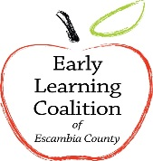 Early Learning Coalition of Escambia County

Holiday Schedule
FISCAL YEAR 2018-2019

HOLIDAY OBSERVED DATE

Independence Day (Fourth of July) Wednesday, July 4, 2018
Labor Day Monday, September 3, 2018
Columbus Day Monday, October 8, 2018
Veterans Day (Observed) Monday, November 12, 2018
Thanksgiving Day Thursday, November 22, 2018
Day After Thanksgiving Friday, November 23, 2018
Christmas Eve Monday, December 24, 2018
Christmas Day Tuesday, December 25, 2018
New Year’s Day Tuesday, January 1, 2019
Martin Luther King Jr. Day Monday, January 21, 2019
Presidents’ Day Monday, February 18, 2019
Memorial Day Monday, May 27, 2019

