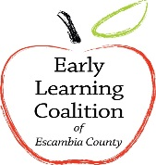 Early Learning Coalition of Escambia County

School Readiness Approved Provider Holiday Schedule
FISCAL YEAR 2016-2017

The following holiday schedule is the only Coalition approved holidays for which the provider will received reimbursement. Pursuant to Rule 6M-4.500 (a) (b) (c) F.A.C.

HOLIDAY OBSERVED DATE

Independence Day (Fourth of July) Monday, July 4, 2016
Labor Day Monday, September 5, 2016
Columbus Day Monday, October 10, 2016
Veterans Day Friday, November 11, 2016
Thanksgiving Day Thursday, November 24, 2016
Day After Thanksgiving Friday, November 25, 2016
Christmas Eve Friday, December 23, 2016
Christmas Day Monday, December 26, 2016
New Year’s Day Monday, January 2, 2017
Martin Luther King Day Monday, January 16, 2017
Presidents’ Day Monday, February 20, 2017
Memorial Day Monday, May 29, 2017

